Declarative vs. imperative
Declarative means you describe the end state you want and let the tool figure out how to get there. You write "this PVC should exist, bound to StorageClass standard," and Terraform compares that to reality and makes whatever changes close the gap. You don't say how; you say what should be true.
Imperative means you specify the actions to perform, in order. "Scale CoreDNS to 2 replicas, wait until Running, then run nslookup to verify." You're issuing commands, not describing a target.
"Permanent state" vs. "cluster-owned"
"Permanent state" refers to configuration you own and want to persist and version-control. The PVC and your app's Deployment are your objects — you authored them, they belong to your application, and you want the corrected StorageClass committed to a file so it never drifts back. Terraform keeps a state file recording that these objects are under its management, so terraform plan can always diff desired-vs-actual.
"Cluster-owned" refers to components the platform itself owns and manages — CoreDNS is one. It ships with Kubernetes, lives in kube-system, and is reconciled by the control plane, not by you. If you put CoreDNS into your Terraform state, you'd be claiming ownership of something the cluster already owns, creating a tug-of-war over its replica count. So you don't adopt it — you just perform a one-off restore action (Ansible) and leave ownership where it belongs.
That's the whole logic: own it and want it permanent → declarative (Terraform); don't own it, just need an action → imperative (Ansible).
Where each sits in the architecture
Here's a map of the cluster with the two tools' zones of responsibility marked:
Here's where the two tools sit relative to the cluster:
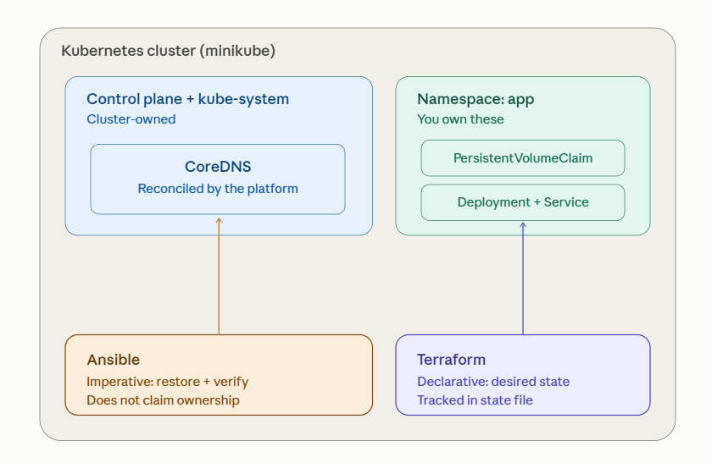
Reading the diagram from the split down the middle:
The left column is the boundary you don't cross. CoreDNS lives in kube-system, part of the control plane's domain. The cluster's own controllers watch it and reconcile it. Ansible reaches in from below only to perform an action — scale it back to 2 replicas, wait, confirm nslookup resolves — and then leaves. It never records "I own CoreDNS," so there's no ongoing tug-of-war between your tooling and the platform's reconciler. That's what "imperative, cluster-owned action" means: a one-time repair on something someone else owns.
The right column is your territory. The PVC and the Deployment/Service in the app namespace are objects you authored. Terraform holds them in its state file, so terraform plan can always compare "what I declared" against "what's live" and show the diff. When the StorageClass was wrong, the fix wasn't a command to run once — it was a correction to the declared desired state, committed so it persists and can't silently drift back. That's "declarative, permanent state."
The deciding question for any Kubernetes object is simply: do I own this, and do I want the fix to persist?
- Yes to both → declarative tool (Terraform), tracked in state.
- No — it's platform-owned, I just need it working again → imperative tool (Ansible), act and exit.
The same logic generalizes beyond these two tools. "Declarative + owned" is also what GitOps (Argo CD, Flux) handles; "imperative + operational" is what a kubectl one-liner or an operator's runbook step handles. Terraform and Ansible are just the two representatives of those two modes in your lab.

